**DAILY ONLINE ACTIVITIES SUMMARY**

|  |  |  |  |  |  |  |  |  |
| --- | --- | --- | --- | --- | --- | --- | --- | --- |
| **Date:** | **05-07-2020** | | | | | **Name:** | **Rakesh M Kotian** | |
| **Sem & Sec** | **8 th sec-b** | | | | | **USN:** | **4al16cs072** | |
| **Online Test Summary** | | | | | | | | |
| **Subject** | | **-** | | | | | | |
| **Max. Marks** | | **-** | | **Score** | | |  | |
| **Certification Course Summary** | | | | | | | | |
| **Course** | **Python for machine learning** | | | | | | | |
| **Certificate Provider** | | | **Great learning** | | **Duration** | | | **6 hours** |
| **Coding Challenges** | | | | | | | | |
| **Problem Statement:** | | | | | | | | |
| **Status:solved** | | | | | | | | |
| **Uploaded the report in Github** | | | | | **yes** | | | |
| **If yes Repository name** | | | | | **Rakeshkotian08** | | | |
| **Uploaded the report in slack** | | | | | **yes** | | | |

Online Test Details: (Attach the snapshot and briefly write the report for the same)

Certification Course Details: (Attach the snapshot and briefly write the report for the same)

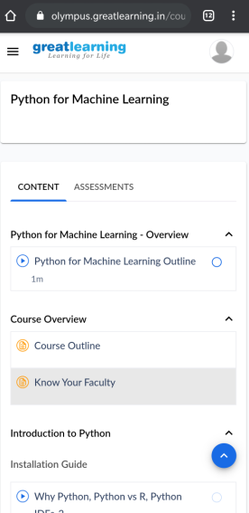

|  |  |
| --- | --- |
| #inserting zeros  arr=[1,0,2,3,0,4,5,0]  i=0  while i < len(arr)-1:    if(arr[i]==0):      arr.insert(i+1,0)      del arr[len(arr)-1]      i=i+2    else:      i+=1  print(arr)  #inserting zeros  arr=[1,0,2,3,0,4,5,0]  i=0  while i < len(arr)-1:    if(arr[i]==0):      arr.insert(i+1,0)      del arr[len(arr)-1]      i=i+2    else:      i+=1  print(arr)   |  | | --- | |  | |